1) Create one jenkins job using the below code and create three stages.

stage1: Git clone to download the source code.

stage2: Sonarqube Integration to check the quality of code

**### Prerequisites**

1. EC2 instance with Java installed

2. Use t2.large with atleast 20gb memory to run sonarqube.

1. MySQL Database Server or MyQL RDS instance.

**### Installation**

Install java 1.8 version

```sh

yum install java-1.8*

* **yum update**
* **ssudo wget https://dev.mysql.com/get/mysql57-community-release-el7-11.noarch.rpm**
* **sudo yum localinstall mysql57-community-release-el7-11.noarch.rpm**
* **rpm --import https://repo.mysql.com/RPM-GPG-KEY-mysql-2022**
* **sudo yum install mysql-community-server**
* **sudo systemctl start mysqld.service**

sudo yum install mysql-community-server

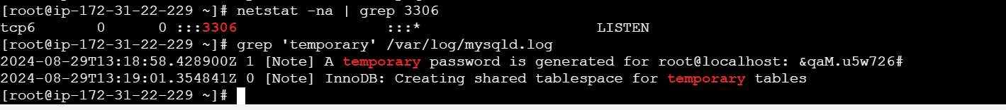

* **Download & unzip SonarQube 6.0**
* **# cd /opt**
* **# wget https://binaries.sonarsource.com/Distribution/sonarqube/sonarqube-6.6.zip**
* **# unzip sonarqube-6.6.zip**
* **# mv /opt/sonarqube-6.6 /opt/sonar**

**CREATE DATABASE sonar CHARACTER SET utf8 COLLATE utf8_general_ci;**

**Integrate with sonarcube scanner in Jenkins**

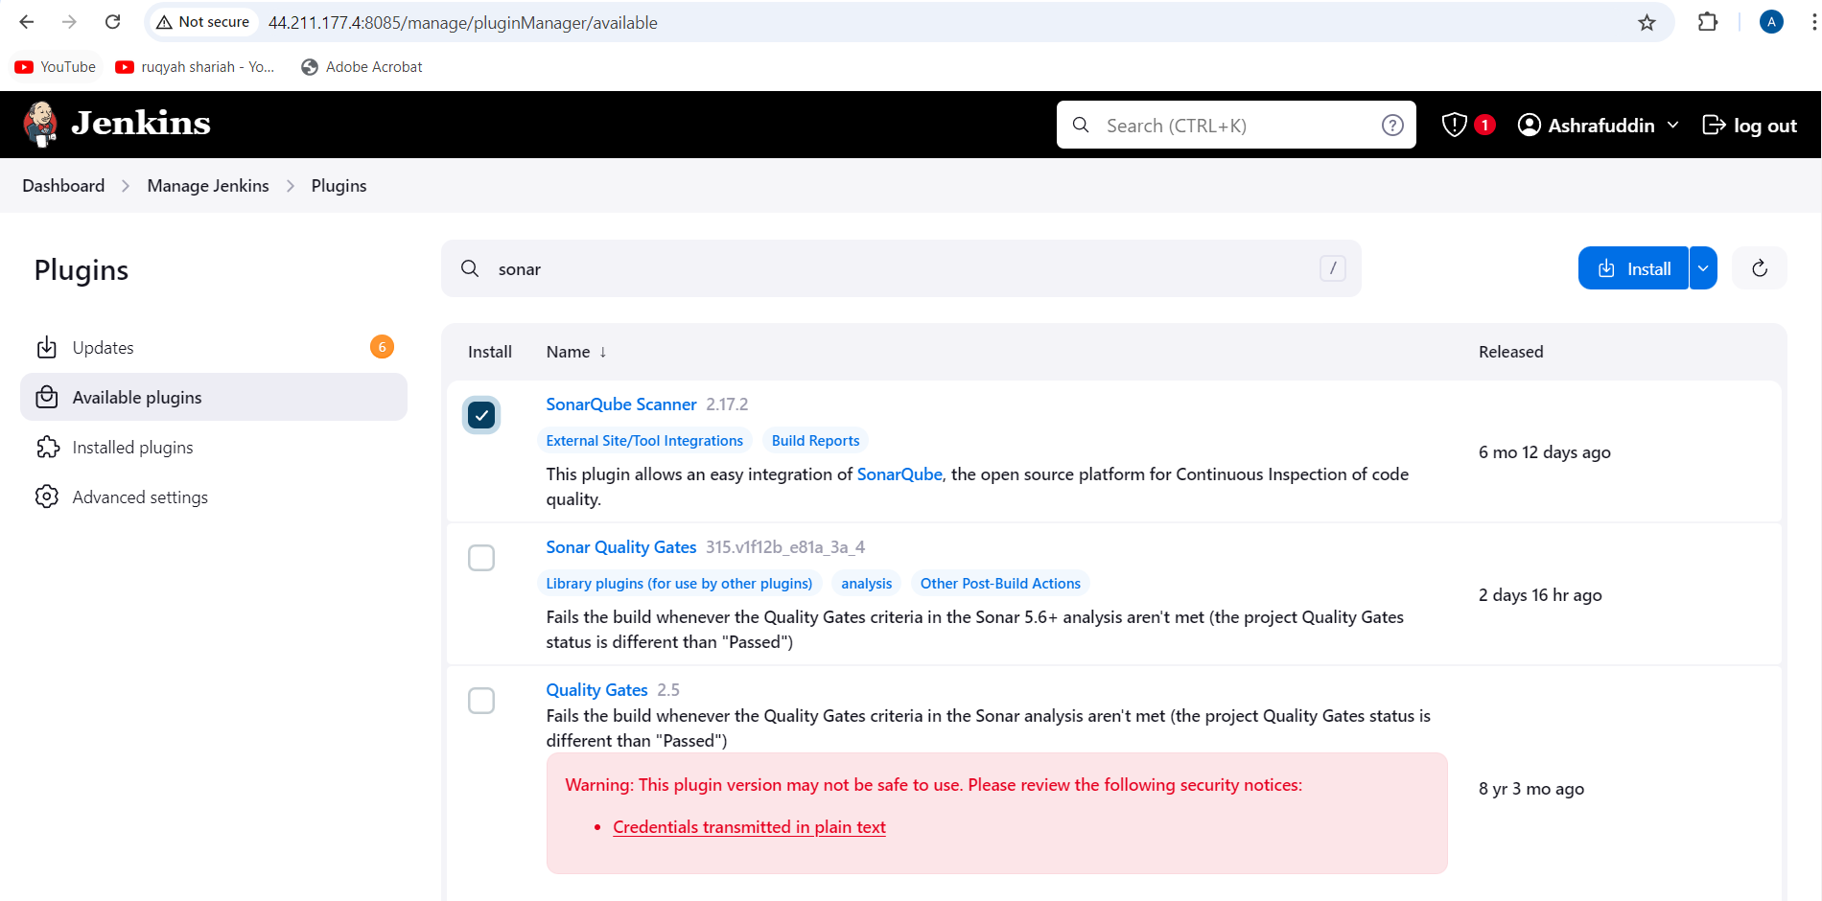

stage3: Slack Integration to send the alerts to slack.

URL: <https://github.com/betawins/VProfile-1.git>

2) 1) Create one jenkins job using the below code and create three stages.

stage1: Git clone to download the source code.

stage2: Sonarqube Integration to check the quality of code

* yum -y install docker
* systemctl start docker
* docker pull sonarqube
* docker images

docker run -itd -p 9002:9000 sonarqube

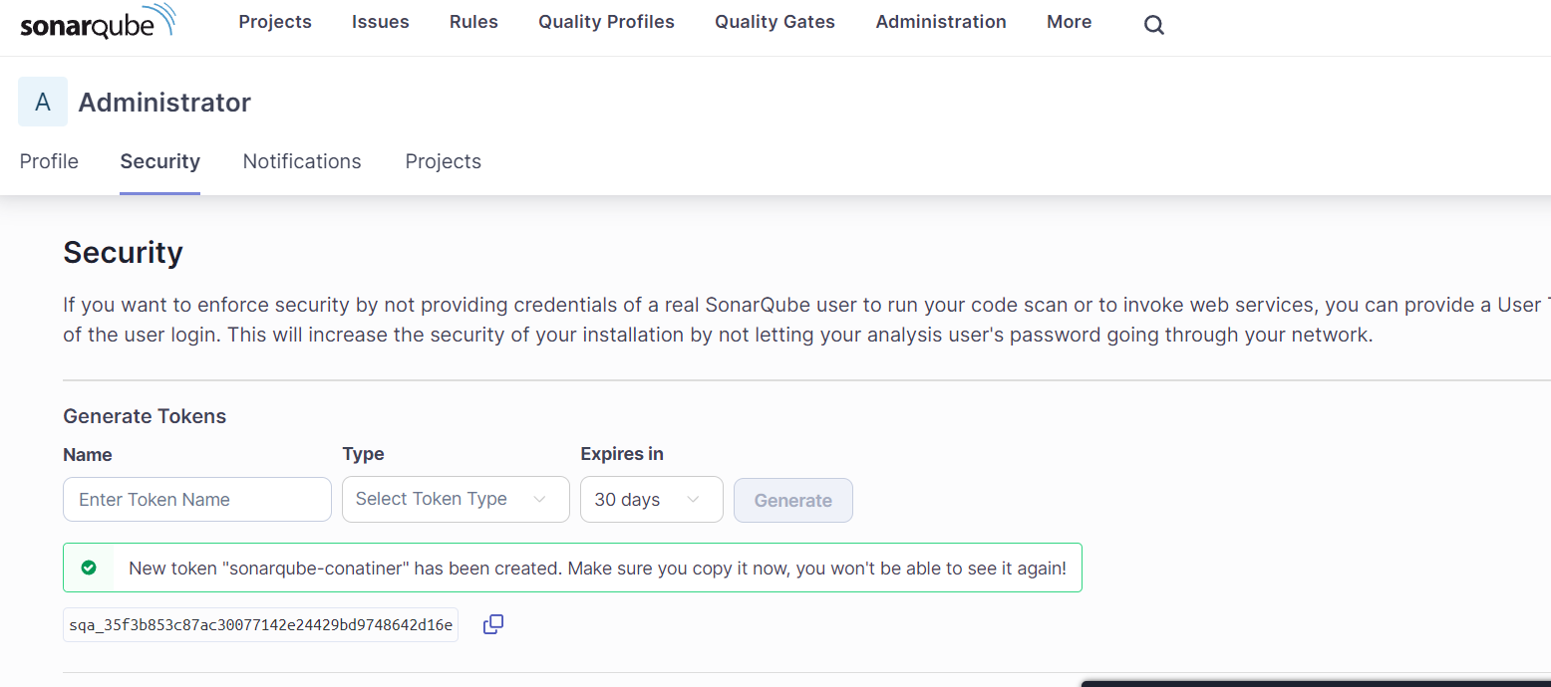

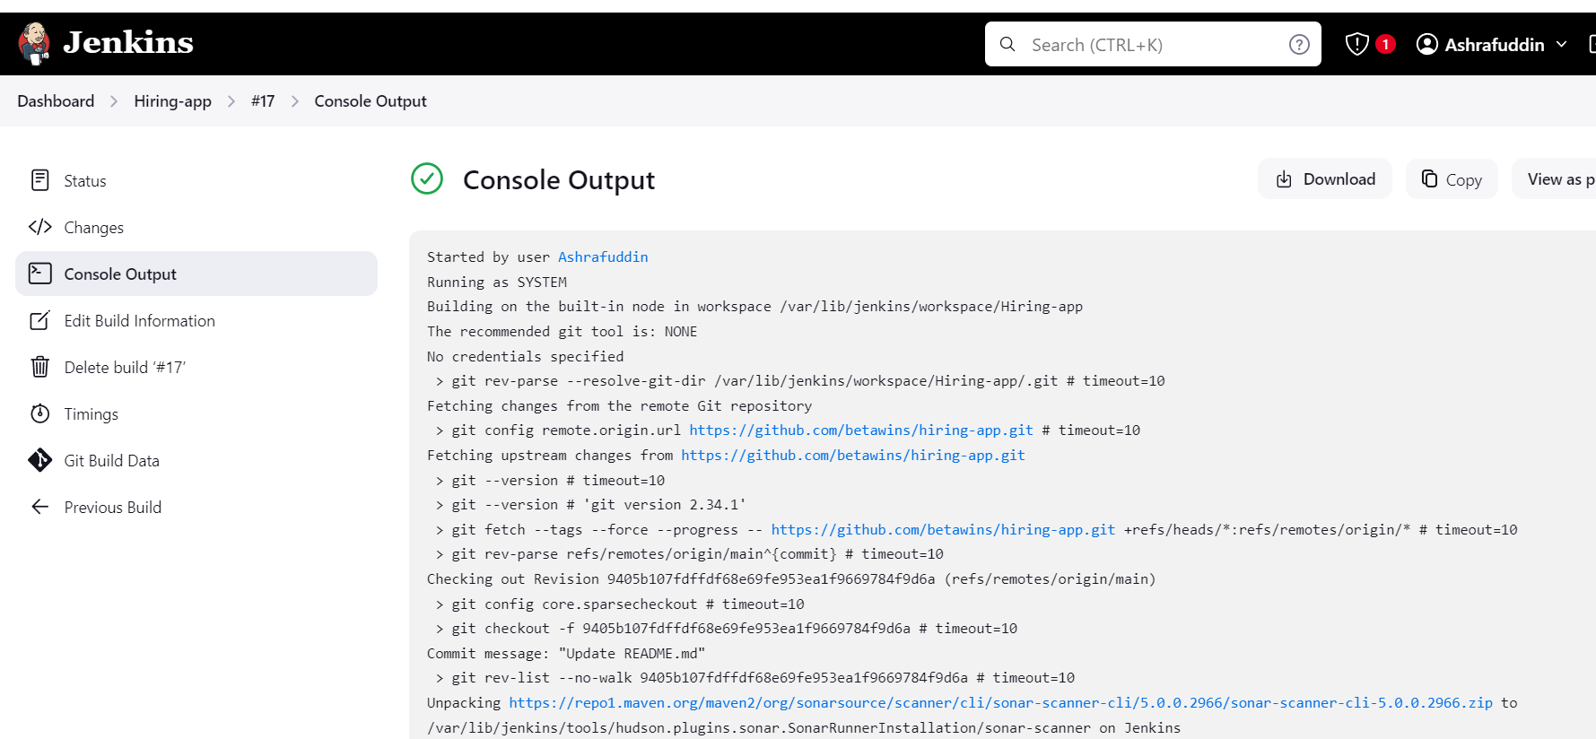

stage3: Slack Integration to send the alerts to slack.

URL: https://github.com/betawins/hiring-app.git